Geometry: Unit 13, Lesson 4
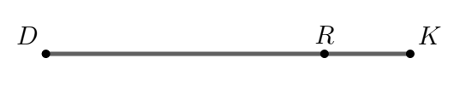
- Line segment $DK$ is shown, where point $R$ lies on the segment. The ratio of $DR$ to $RK$ is $7 :2$. If $RK=28$, what is the value of $DK$?

$$DK=126$$

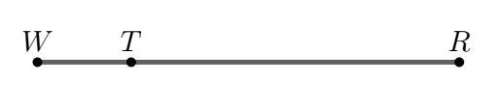
- Lines segment $WR$ is shown, where point $T$ lies on the segment. The ratio of $WT$ to $TR$ is $2 :7$. What is the ratio of $WR$ to $TR$?

$$9 :7$$
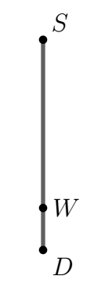
- Line segment $DS$ is shown, where point $W$ lies on the segment. The ratio of $DW$ to $DS$ is $\frac{2}{13}$. $DS=260$. What is the length of $\overline{SW}$?

$$220$$

